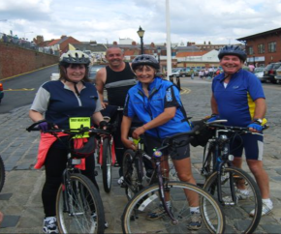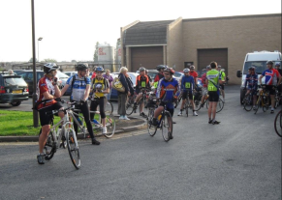

Dewsbury Ambulance Charities
Cycle Ride 2018
Sunday 29th July 2018
- Dewsbury Hospital to Bridligton Harbour (76 miles) Start 0800hrs.
- Back up vehicles and refreshment stops en-route.
- Gels and route maps provided.
- Return journey on Coach (Lyles).
- Bicycles can also be returned on back-up Truck.
- Sponsored riders who raise more than £30 free entry.
- Non sponsored entry fee £30.
- Shower and changing facilites at Bridlington.
- Pre registration essential (All forms @ http://dewsambcharities.org.uk).
- ALL MONIES RAISED WILL GO DIRECTLY TO THE DAC (for more information visit dewsambcharities.org.uk).
- Check out the route Strava- https://www.strava.com/routes/13228777

For more information see DAC web page or email c.fothers@googlemail.com
Facebook- https://www.facebook.com/events/2061552050797205/

